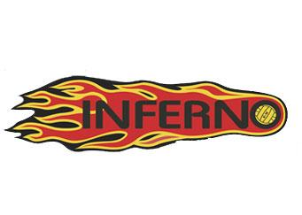
KW Water Polo

Coaching Application
Applicant Information
Full Name:
Address:
Phone:
Email:
What age division(s) are you interested in coaching? (10U, 12U,14U Boys, 14U Girls, 16U Boys, 16U Girls, 18U Boys, 18U Girls, ANY):
Coaching Philosophy
Please use this section to describe your philosophy as a coach. Please include:
- are you focused on recreation or competition
- what is your approach to encouraging and motivating athletes
- what are your expectations for player behavior and attendance
- what are the ideal number of practices per week for the age group you wish to coach
- how you will maintain competitiveness while developing new athletes
Enter your information here:

Growing the Sport
Please use this section to describe how you would contribute to the growth of water polo in KW.
Enter your information here:

Coaching Plan
Please use this section to describe how you will develop the athletes you coach. Please include:
- primary goals you hope to achieve by mid and end of season
- practice plan summarized monthly throughout for the season
- tournaments you plan to enter (should be in the range of 4-5)
- how you would support a seamless development plan and cooperation from division to division
Enter your information here:

Experience
Please use this section to describe your experience and coaching success. Please include:
- coaching designations
- any training which pertains to motivating and developing young players
- achievements of teams coached in past 3 years – year, level, your role, achievement
Example: 2017, 18U Boys, Assistant Coach, NCL Eastern National Silver Medalists
Enter your information here:

